**Scrum Development Team**

It is a self-organizing, Transform PBI’s into increments, cross-functional team of people who are at the core of the Scrum development team structure.

It is the team that is responsible for building the actual product increment and meeting the sprint goal.

The success of Scrum largely depends on how successful the development team is.

They are responsible for delivering the product with value specified with the duration of the work that is sprint.

### **Ideal size of the Development Team**

Scrum prescribes that the ideal team size is between 3 - 9 team members (*3 and 9 inclusive*). It doesn't include the Scrum Master and Product owners unless they are also executing the work of the sprint backlog.

So, what's the logic for this range? It's quite simple! A team size of less than three will not be cross-functional. They might not have all the skillset required to get the sprint work done.

A team size of more than 9 creates communication challenges. It leads to inefficiencies in day-to-day coordination. Usually, Scrum teams prefer to have an optimal team size of 5-7 team members.

**Development**

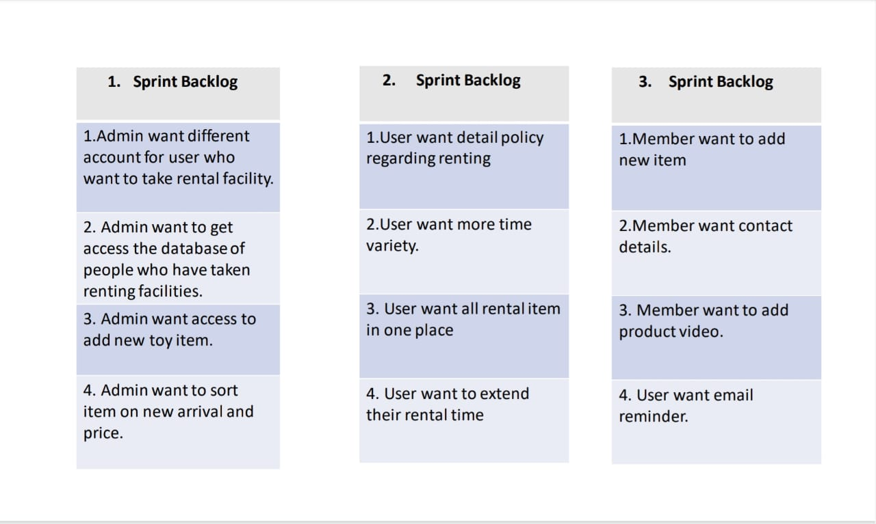

• In the development phase according to the priority and schedule whatever has selected in the Sprint backlog by Scrum Master and development team will be created.

• In 1st sprint backlog for the first point new account type will be created for the user who want to take rental facility and a separate database will be created.

• In 2nd point admin will be given privileges to access the database so that s/he can easily check the customer details.

• In 3rd point admin will be given the access to add new item and its details to be shown in the software interface.

• In 4th point after getting the input from the supplier sorting option will be added to the software so that all toys can be sorted on the basis of price and new arrival time.

**Development**

• In the second sprint,

• As per 1st point a new page containing all the details user policy will be added for the user.

• As per 2nd point more time options like 1 week, 2-week 3 week will be added to the rental time option. • As per 3rd point a particular wallet will be created for user where all item ordered by them can be seen. • As per 4th point there will be an added feature named extend which will allow the user to keep the toy for extended period.

**Development**

• As per the 3rd Sprint,

• As per 1st point member will be given access to add new item from their account.

• As per 2nd point a page containing all the admin, support team will be provided for the member if they want to contact any of them.

• As per 3rd point member will be given a slot just below the product name where they can upload toy videos to promote and give a better view for the customer.

• As per 4th point there will be an reminder for user through email about the remaining days of subscription.

**Scrum Testing:**

It is the testing to verify the software application requirement are met or not.

**Lifecycle:**

* Impact assessment
* Planning
* Daily Scrum
* Review Meeting
* Done = Releasable

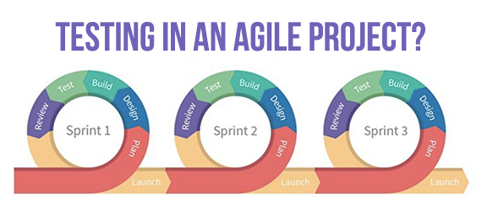

**Advantages:**

* Save time and money
* Flexibility and adaptability
* Provide regular feedback
* Fix issues easily

**Characteristics of Development team:**

* Development team is not an individual, it is a team, but it’s a group of individuals working together to achieve the goals (product increment, customer satisfaction, balance of risk).
* The development team is **self-organizing teams.** No one (not even the Scrum Master) directs the Development Team on how to convert Product Backlog into Increments of potentially releasable functionality.

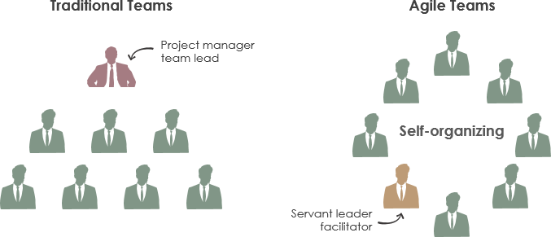

* Development Teams are generally **cross-functional**. It comprises of members with varied skills. As a team, these combined skillsets are necessary to create a product Increment.

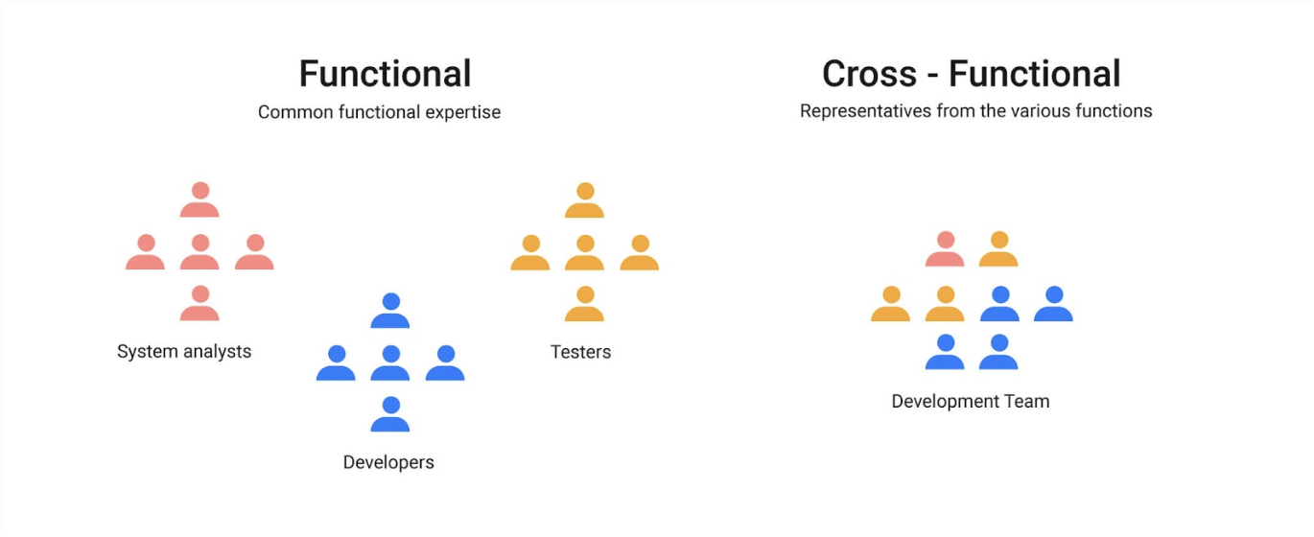

* Development Team members do not have **individual titles**. Each member is identified only as a part of the Development Team, irrespective of the work being performed by the person.
* Scrum recognizes no **sub-teams** in the Development Team, although it may be formed of domains like testing, business analysis, operations, or architecture.
* The Scrum guide recommended that; the development team size must be 3 to 9. Not too small or not too big.

**RESPONSIBILITIES:**

**1. Perform Sprint Execution:**

During sprint execution, the development team members perform the tasks of designing, building, integrating, and testing product backlog items into increments of potentially shippable functionality. For this, they self-organize and mutually decide how to plan, manage, carry out, and communicate the work. The development team spends a good amount of its time performing sprint execution.

**2. Inspect and Adapt:**

All the development team members need to participate in the daily Scrum. During this time the team members collectively inspect their progress toward the sprint goal and adapt the plan for the current day’s work. If some of the team members do not take part in the daily stand up, the team can miss vital pieces of the bigger picture and may fail to attain the sprint goal.

**3. Groom the Product Backlog:**

In each sprint, the development team must dedicate an ample amount of time preparing for the next sprint. A large part of that work must be focused on product backlog grooming. This includes creating and refining, estimating, and prioritizing product backlog items. In every sprint, the development team should allocate up to 10% of its overall capacity to assist the product owner with all these activities.

**4. Plan the Sprint:**

The development team participates in sprint planning that takes place at the beginning of every sprint. In collaboration with the product owner, the development team helps establish the goal for the next sprint. This is facilitated by the Scrum Master. Once the goal is defined, the team determines a high-priority subset of the product backlog items which they should build to achieve that goal.

The time required for sprint planning is directly proportional to the size of the sprint. Sprint planning duration for a two-week sprint is about half a day. A four-week sprint might need up to a full day for sprint planning. This planning also follows an iterative pattern. Unlike traditional project planning methods, the team does not focus on an elaborate and uncertain plan at the beginning of its development effort. Rather, it makes a series of granular, more certain, and more detailed plans at the start of each sprint.

**5. Inspect and Adapt the Product and Process:**

Towards the end of each sprint, the development team involves two inspect-and adapt activities: sprint review and sprint retrospective. In the sprint review, the development team, product owner, Scrum Master, stakeholders, sponsors, customers, and the interested members of other teams also participate. They review the just-completed features of the current sprint and discuss how to progress in an efficient way. The sprint retrospective is where the **Scrum team** inspects and adapts its Scrum process and technical practices to improve the way it uses Scrum to deliver the best business value

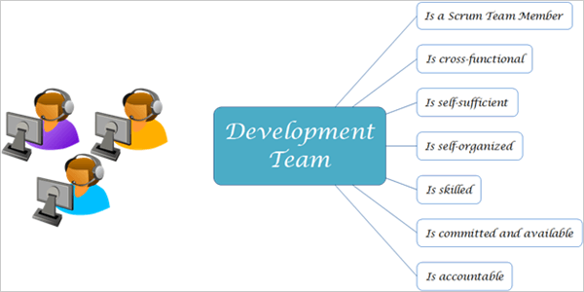

## **Essential qualities of a Scrum Development team:**

### **1. Pair programming:**

The first and foremost job of a programmer in a development team is to work in collaboration with another one at the same workstation. One programmer (the driver) writes the code and the other one (the navigator) reviews each line of the code.

### **2. Understanding of TDD, BDD:**

Every development team member should be well versed with advanced techniques of using automated unit tests to drive the design software and get rid of dependencies in the team.

### **3. Self-motivation:**

Self-motivation is the biggest driver of efficiency, one which is usually seen in successful development teams. There is no senior-junior hierarchy within the team. The entire team should work on its own.

### **4. Team player:**

The very foundation of Scrum is built on teamwork as a summation of individual efforts. These teams achieve bigger goals working together than as individuals. Every person in the team should be more of a team player and less of an individual team member.